Week 7 Workshop

### COS10025 – Technology in an Indigenous context project



Acknowledgement of Country

We respectfully acknowledge the Wurundjeri People of the Kulin Nation, who are the Traditional Owners of the land on which Swinburne’s Australian campuses are located in Melbourne’s east and outer-east, and pay our respect to their Elders past, present and emerging.

We are honoured to recognise our connection to Wurundjeri Country, history, culture, and spirituality through these locations, and strive to ensure that we operate in a manner that respects and honours the Elders and Ancestors of these lands.

We also respectfully acknowledge Swinburne’s Aboriginal and Torres Strait Islander staff, students, alumni, partners and visitors.

We also acknowledge and respect the Traditional Owners of lands across Australia, their Elders, Ancestors, cultures, and heritage, and recognise the continuing sovereignties of all Aboriginal and Torres Strait Islander Nations.

## Workshop 7

**The aim of today’s class is to focus on Design Justification and receive feedback from the facilitator.**

Weekly Project plan (re-cap) Activity 1: Design Justification

# Weekly Project plan

Week 7 – Design Justification

The team will work on justifying your team design ideas (all 5-design idea)

1. Why your team decided to choose those designs?
2. Which two designs were best choice out of the five?
3. Why haven’t the team chosen the other 3 design ideas?

Week 8 – Design debate

* Your team should justify your low priority design ideas.
* Your team must work on how to make those 3 low priority design ideas as a good one.

Week 9 – Design finalisation

* Finalise your team design ideas
* Go through team presentation expectations

# Weekly Project plan

Week 10 – Design Evaluation

The team will work on evaluating your team design ideas (all 5-design idea)

* Use the design criteria document to check
* Go through the final project reflection report

Week 11 – Design Presentation

* Your team should present your design ideas during workshop on-campus compulsory.
* Each team member will present for 2-3 mins.

Week 12 – Final report submission

* Submit your individual final project reflection report
* Submit your peer assessment report

## Design Justification

Week 7 Activity plan

* Facilitator will give you a peer justification sheet
* Each student will justify all design ideas in your team and submit the document to your facilitator for collating the scores in a final average scoring sheet
* Complete your scoring and record any evidences for your score (3 or 2 or 1 point)
* Write your comments - why did you assessed with a particular score.

The first 1 hour of your workshop is for individual peer justification

* + Submit your physical sheets to your facilitator for collating the scores

The second 1 hour of your workshop is for deciding your 2 BEST and 3 LEAST designs

* + Your facilitator will spend 10 minutes with each team sharing the average score for all design
  + Decide you 2 BEST design and 3 LEAST designs

Design Justification 1 , Wk2, Melb Swin, 102299

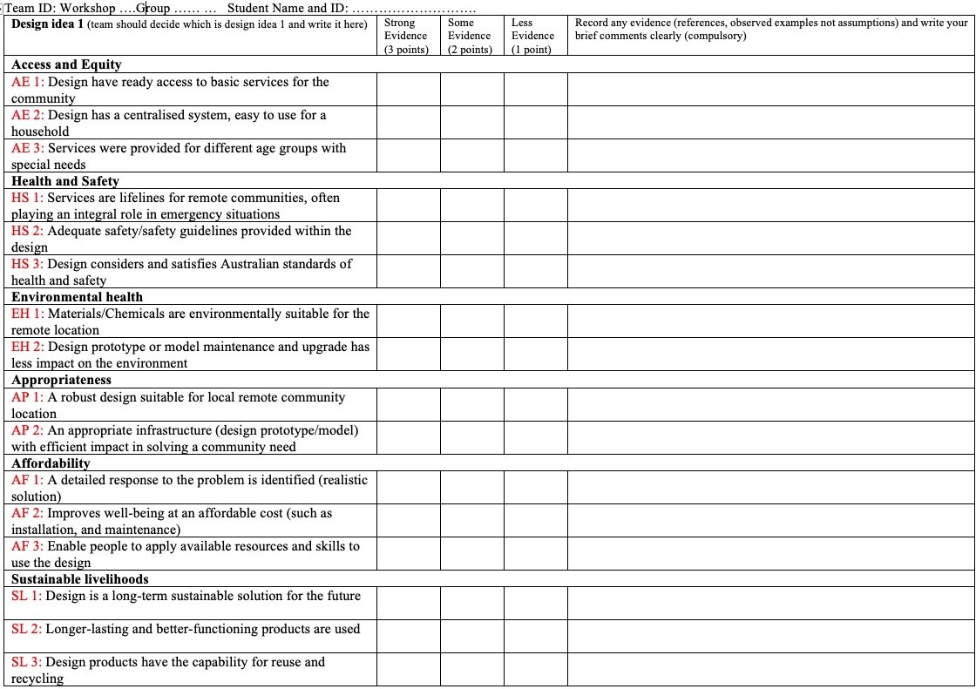

3 or 2 or 1

Brief comments

No tick mark

Don’t leave it blank

## Design Justification (examples)

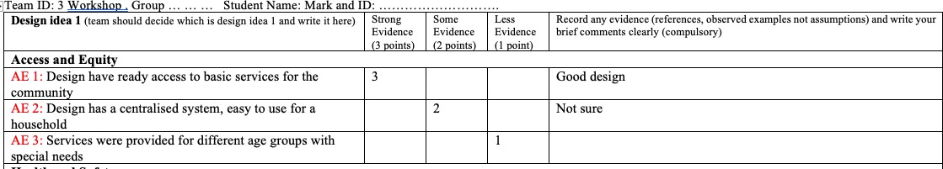

Bad example

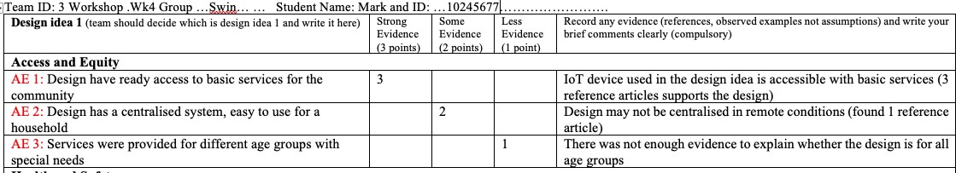

Good example

Design Justification (average score)

|  |  |  |  |  |  |
| --- | --- | --- | --- | --- | --- |
| **Design idea 1** |  | | | | |
| **Access and Equity** | **Member 1** | **Member 2** | **Member 3** | **Member 4** | **Member 5** |
| AE 1 |  |  |  |  |  |
| AE 2 |  |  |  |  |  |
| AE 3 |  |  |  |  |  |
| **Health and Safety** | **Member 1** | **Member 2** | **Member 3** | **Member 4** | **Member 5** |
| HS 1 |  |  |  |  |  |
| HS 2 |  |  |  |  |  |
| HS 3 |  |  |  |  |  |
| **Environmental health** | **Member 1** | **Member 2** | **Member 3** | **Member 4** | **Member 5** |
| EH 1 |  |  |  |  |  |
| EH 2 |  |  |  |  |  |
| **Appropriateness** | **Member 1** | **Member 2** | **Member 3** | **Member 4** | **Member 5** |
| AP 1 |  |  |  |  |  |
| AP 2 |  |  |  |  |  |
| **Affordability** | **Member 1** | **Member 2** | **Member 3** | **Member 4** | **Member 5** |
| AF 1 |  |  |  |  |  |
| AF 2 |  |  |  |  |  |
| **Sustainable livelihoods** | **Member 1** | **Member 2** | **Member 3** | **Member 4** | **Member 5** |
| SL 1 |  |  |  |  |  |
| SL 2 |  |  |  |  |  |

## Design Justification (average score)

Average score to decide 2 best and 3 least designs

|  |  |  |  |  |  |
| --- | --- | --- | --- | --- | --- |
| **Access and Equity** | **Design 1** | **Design 2** | **Design 3** | **Design 4** | **Design 5** |
| AE 1 |  |  |  |  |  |
| AE 2 |  |  |  |  |  |
| AE 3 |  |  |  |  |  |
| **Health and Safety** |  |  |  |  |  |
| HS 1 |  |  |  |  |  |
| HS 2 |  |  |  |  |  |
| HS 3 |  |  |  |  |  |
| **Environmental**  **health** |  |  |  |  |  |
| EH 1 |  |  |  |  |  |
| EH 2 |  |  |  |  |  |
| **Appropriateness** |  |  |  |  |  |
| AP 1 |  |  |  |  |  |
| AP 2 |  |  |  |  |  |
| **Affordability** |  |  |  |  |  |
| AF 1 |  |  |  |  |  |
| AF 2 |  |  |  |  |  |
| **Sustainable**  **livelihoods** |  |  |  |  |  |
| SL 1 |  |  |  |  |  |
| SL 2 |  |  |  |  |  |

## Activity 1

### Design Justification



1st Activity

Aim : Design Justification

Instructions : ▪ Design Justification

1. Each team member need to justify all design ideas (individual)
2. Use the peer justification rubric to justify each design
3. Give your score for each design idea and submit it to the facilitator
   * + Average Score
4. Facilitator collects your score sheets from all team members
5. Enter all scores and finalise it with an average score
6. The team decides the top 2 best and 3 least design ideas based on the Average score

Teamwork: 1.5 hours

Next week

* Continue working on justifying your team design ideas
* Design debate with your team

